Thoughts about the bembidion movement
  - Sascha Bub, 28.5.26
In this document, I want to share some observations about the current implementation of the bembidion movement and propose possible solutions to overcome current limitations.
The main problem with the current implementation is that bembidions accumulate along edges and in corners formed by impenetrable boundaries. Such boundaries occur where (partly) suitable bembidion habitat is adjacent to unsuitable habitat, which is implemented in such a way that the model bembidions never enter it. Accumulation along edges and in corners is an effect emerging from the implementation of individual-based movement rules. The following plot shows the increased densities of bembidions after some simulation time in a 100 m x 100 m field surrounded by unsuitable habitat.
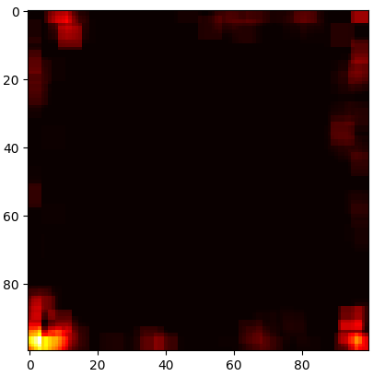
Implementation of individual bembidion movement is simple. Each day, the bembidion decides how many steps (1 to 14) it takes. It then decides for a direction, which is either a 45°-deviation from its last-day heading or a continuation of the walking direction from the previous day. Turning has a probability of 80% (40% per direction) and keeping the previous direction a probability of 20%. Movement is always constricted to a regular 1 sqm-grid.
The following plot shows the possible endpoints of movement for a bembidion that is surrounded only by suitable habitat and that ended its last-days movement heading East. Tints of blue indicate the probability of grid cells to be endpoints of its current-day movement.
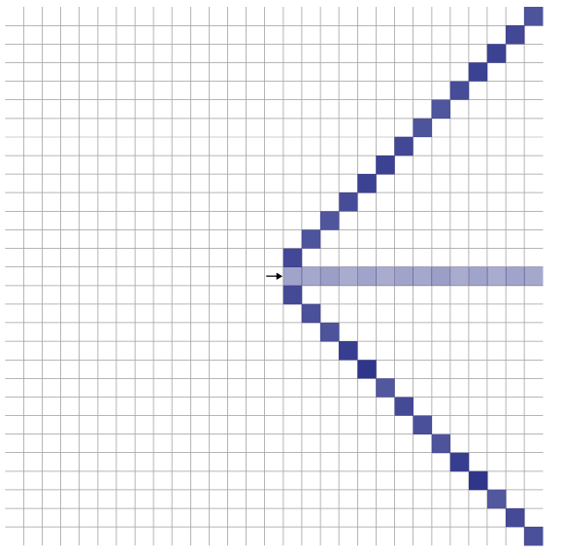
Three features of the implemented bembidion movement become apparent: the Bembidion moves faster in diagonal direction (by a factor of sqrt(2), approximately 41%) than in horizontal or vertical direction, and the number of points it can reach is fairly limited. There are only 42 grid cells where it can end its movement. Also, the implemented preference for turning compared to continuing straight shows in different probabilities.
Movement becomes more complicated when the bembidion is about to make a step into an unsuitable habitat (grey in the next plot). In this case, random turns by 45° (randomly clockwise or anti-clockwise) are added until the bembidion finds a direction where it can make its step. If it isn’t able to find a suitable direction within ten random turns, it ends its movement for this day.
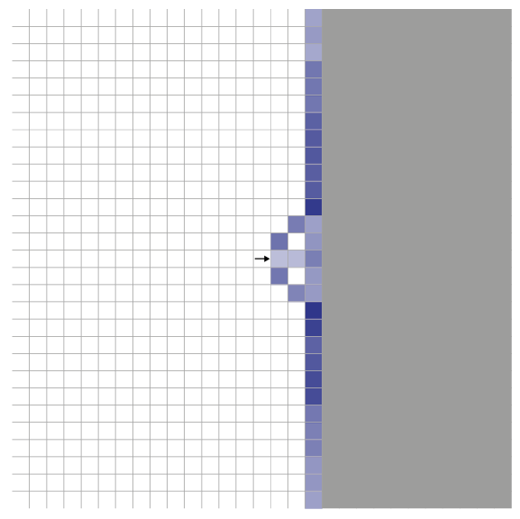
This implementation results in bembidions ending up next to boundaries (e.g., see plot above). Only on the next day it could turn into a direction leading away from the edge, but even then, in the above example, only with a probability of 40%. In effect of this implementation, bembidions have an increased probability to be found along edges.
In the following, simple modifications of the implementation are shown that allow mitigating or even overcoming the increased likelihood of bembidions ending their movement along edges.
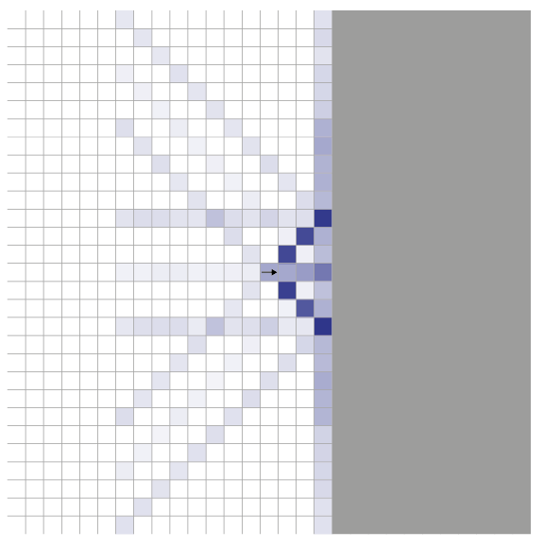
In the first variant (plot above), bembidions that are about to move in unsuitable habitat get more freedom in choosing a new direction: instead of being allowed to turn in 45° steps, they choose their new direction freely and uniformly from the eight available directions (as above, up to ten tries). This adds at least some likelihood that the bembidion ends its daily movement away (and heading away) from a boundary. However, overall likelihood to end up along the edge remains increased.
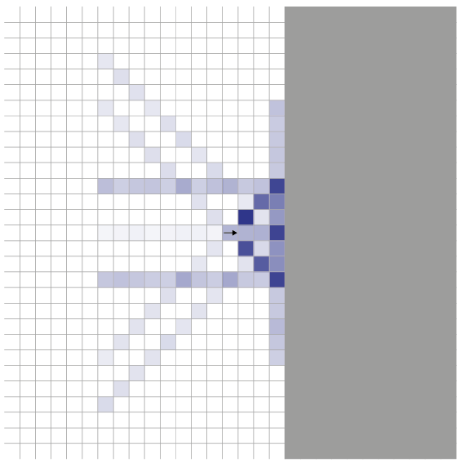
In a second variant (plot above), the bembidion first turns around 180° and then decides for turning as this would be the beginning of its daily movement (see above). This results in the bembidions being repulsed more from boundaries, with a more balanced probability to end its movement next to an edge. However, as at the next day there is still only a 40% chance to move away from the boundary, once there, this would presumably still lead to accumulation along edges.
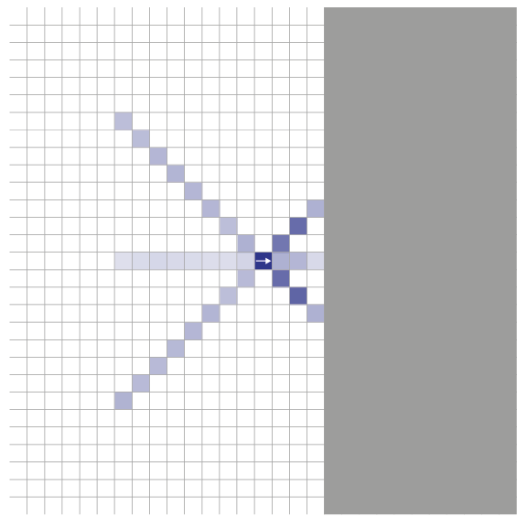
In the third variant, the bembidion simply turns around 180° if it is about to enter unsuitable habitat. Because this virtually always (except at simulation start) leads him back the way it walked before, in this direction will be suitable habitat. The number of cells where the bembidion can end up its day is limited, but there is no increased likelihood along the edges. And even the cells with highest probability to end movement (top one is the cell where the bembidion started its movement; i.e., movement is skipped this day) pose no additional risk for accumulation as the starting direction for next day’s movement points away from the boundary.
The third variant could be a simple modification to ensure dispersal of bembidions without accumulative edge effects.

It should be noted that the implementation of bembidion movement does, overall, not appear very realistic. I wonder whether, both from an ecological and from a technical perspective, other implementations would be better fitting. I wonder if instead of simulating each step it wouldn’t be a better approach to just simulate the endpoints of daily movement. This would allow to mitigate the anisotropy of current movement (diagonal faster than horizontal and vertical) and would give more degrees of freedom to where the movement can end, even if the idea of a preferred multi-day direction is kept. This could be done by assigning a priori probabilities to the cells in the, e.g., 14m-vicinity of a bembidion instead of having this probabilities be the effect of stepwise resolution. These probabilities could factor in direction, habitat quality and, potentially, distance. The following plot shows some conceptual sketches how such a probability map could look like. This could even allow to simulate bembidions crossing small boundaries (e.g., 2m-wide farm roads) that are now impenetrable. I also think that such spatial probabilities could be easier to derive from field observations than rules for movement steps.
Maybe we can discuss this further in our meetings.
